Assignment 10
Using the tables “DEPARTMENTS” and “EMPLOYEES” perform the following queries
- Display the employee details, departments that the departments are same in both the emp and dept. 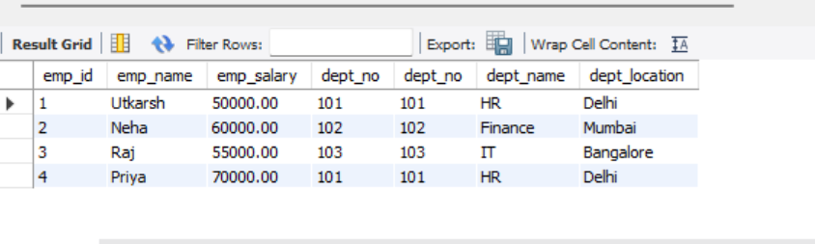

- Display the employee name and Department name by implementing a left outer join.
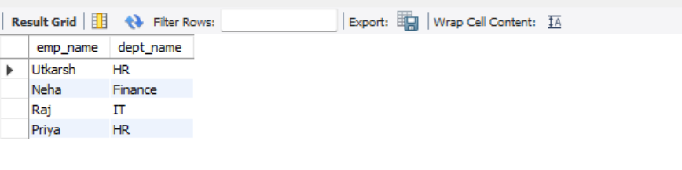

- Display the employee name and Department name by implementing a right outer join.
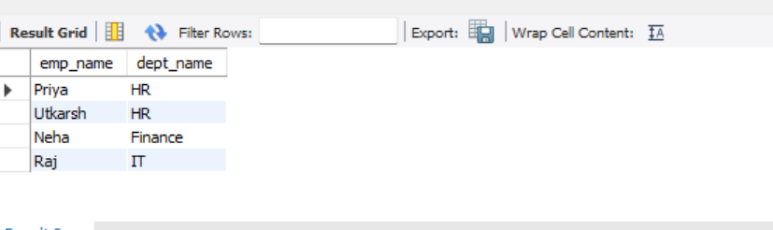
- Display the details of those who draw the salary greater than the average salary
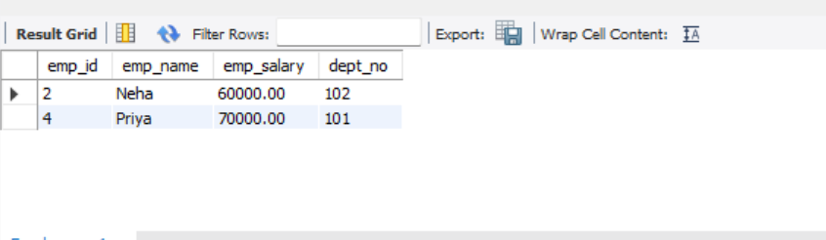
Code:
CREATE DATABASE IF NOT EXISTS experiment10;
USE experiment10;

CREATE TABLE Departments (
dept_no INT,
dept_name VARCHAR(50),
dept_location VARCHAR(50)
);

CREATE TABLE Employees (
emp_id INT,
emp_name VARCHAR(50),
emp_salary DECIMAL(10,2),
dept_no INT
);

INSERT INTO Departments VALUES
(101, 'HR', 'Delhi'),
(102, 'Finance', 'Mumbai'),
(103, 'IT', 'Bangalore');

INSERT INTO Employees VALUES
(1, 'Utkarsh', 50000, 101),
(2, 'Neha', 60000, 102),
(3, 'Raj', 55000, 103),
(4, 'Priya', 70000, 101);

-- (a) Inner Join (same dept)
SELECT *
FROM Employees e
INNER JOIN Departments d
ON e.dept_no = d.dept_no;

-- (b) Left Outer Join
SELECT e.emp_name, d.dept_name
FROM Employees e
LEFT JOIN Departments d
ON e.dept_no = d.dept_no;

-- (c) Right Outer Join
SELECT e.emp_name, d.dept_name
FROM Employees e
RIGHT JOIN Departments d
ON e.dept_no = d.dept_no;

-- (d) Salary greater than average
SELECT *
FROM Employees
WHERE emp_salary > (SELECT AVG(emp_salary) FROM Employees);

